1. **Create a pipeline to fetch the All countries data from Rest API (**[**https://restcountries.com/v3.1/all)**](https://restcountries.com/v3.1/all)) **and save it as parquet file in ADLS.**

Solution:

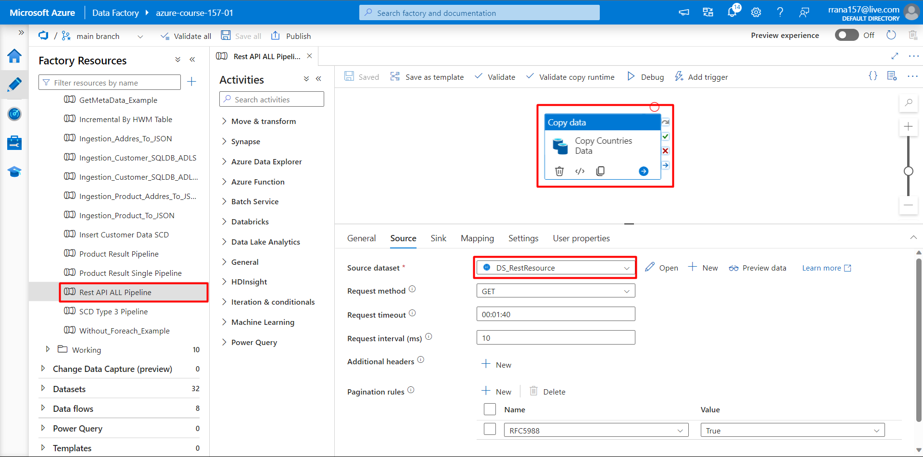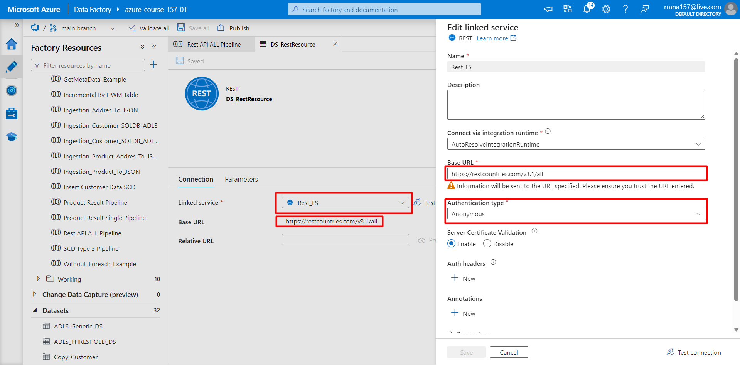

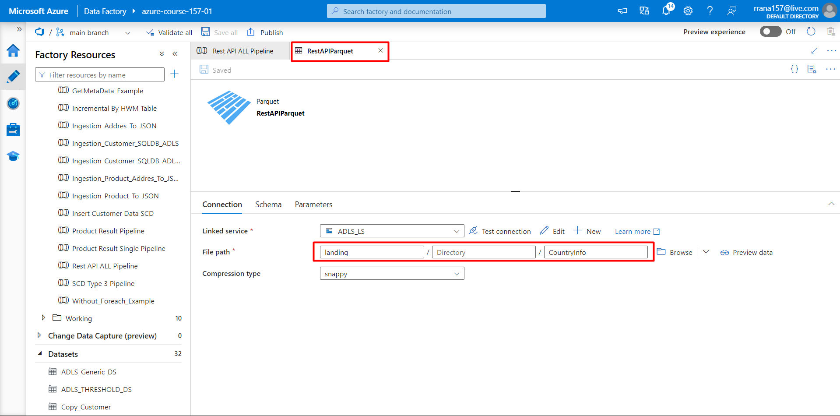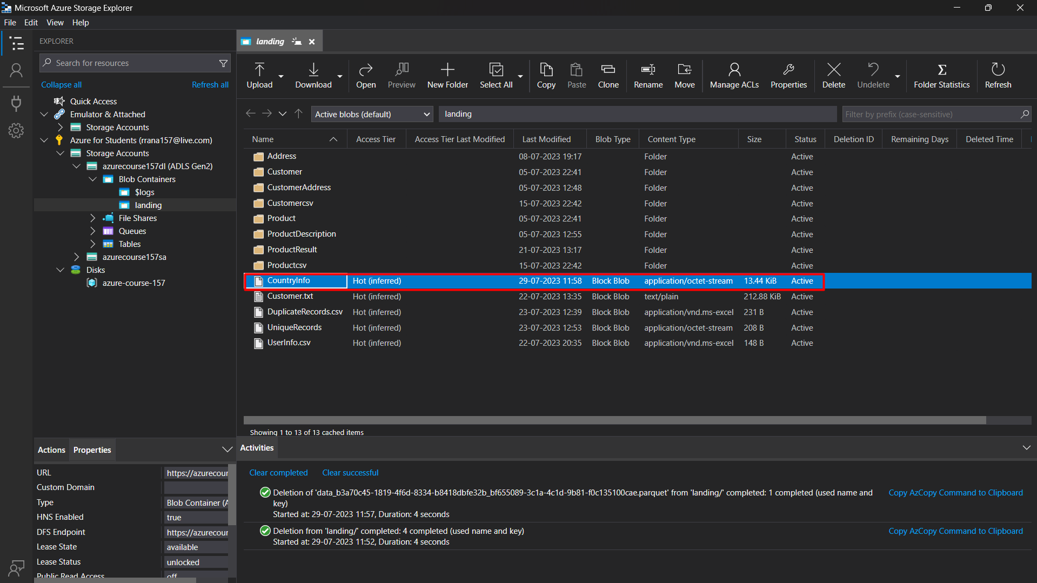

1. **Create a pipeline to fetch the 5 countries (india,us,uk,china,russia) data from Rest API (**[**https://restcountries.com/v3.1/name/{name}**](https://restcountries.com/v3.1/name/%7Bname%7D)**here replace the {name} with Country name like** [**https://restcountries.com/v3.1/name/us)**](https://restcountries.com/v3.1/name/us))**and save it in separate file as JSON with File name equal to Country name.**

Solution:

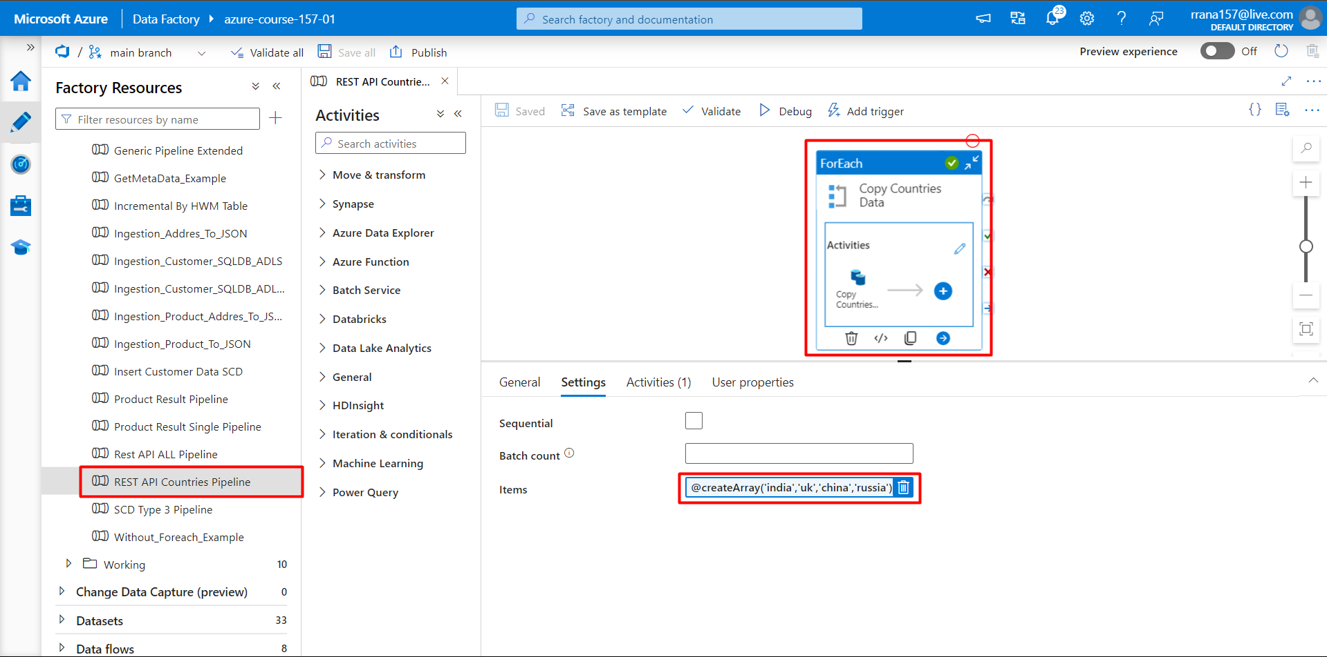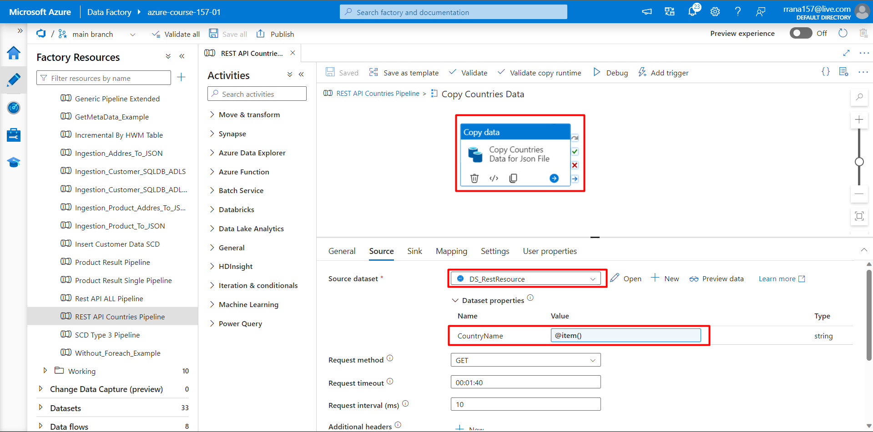

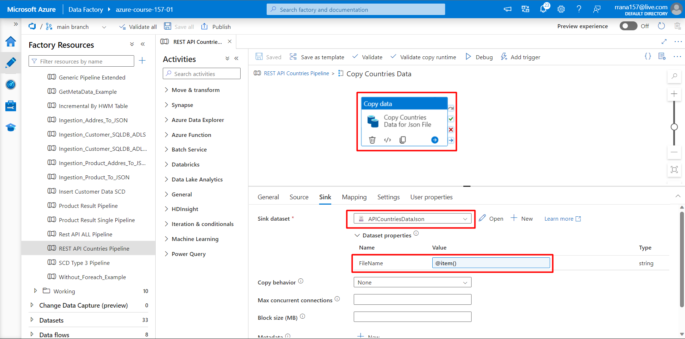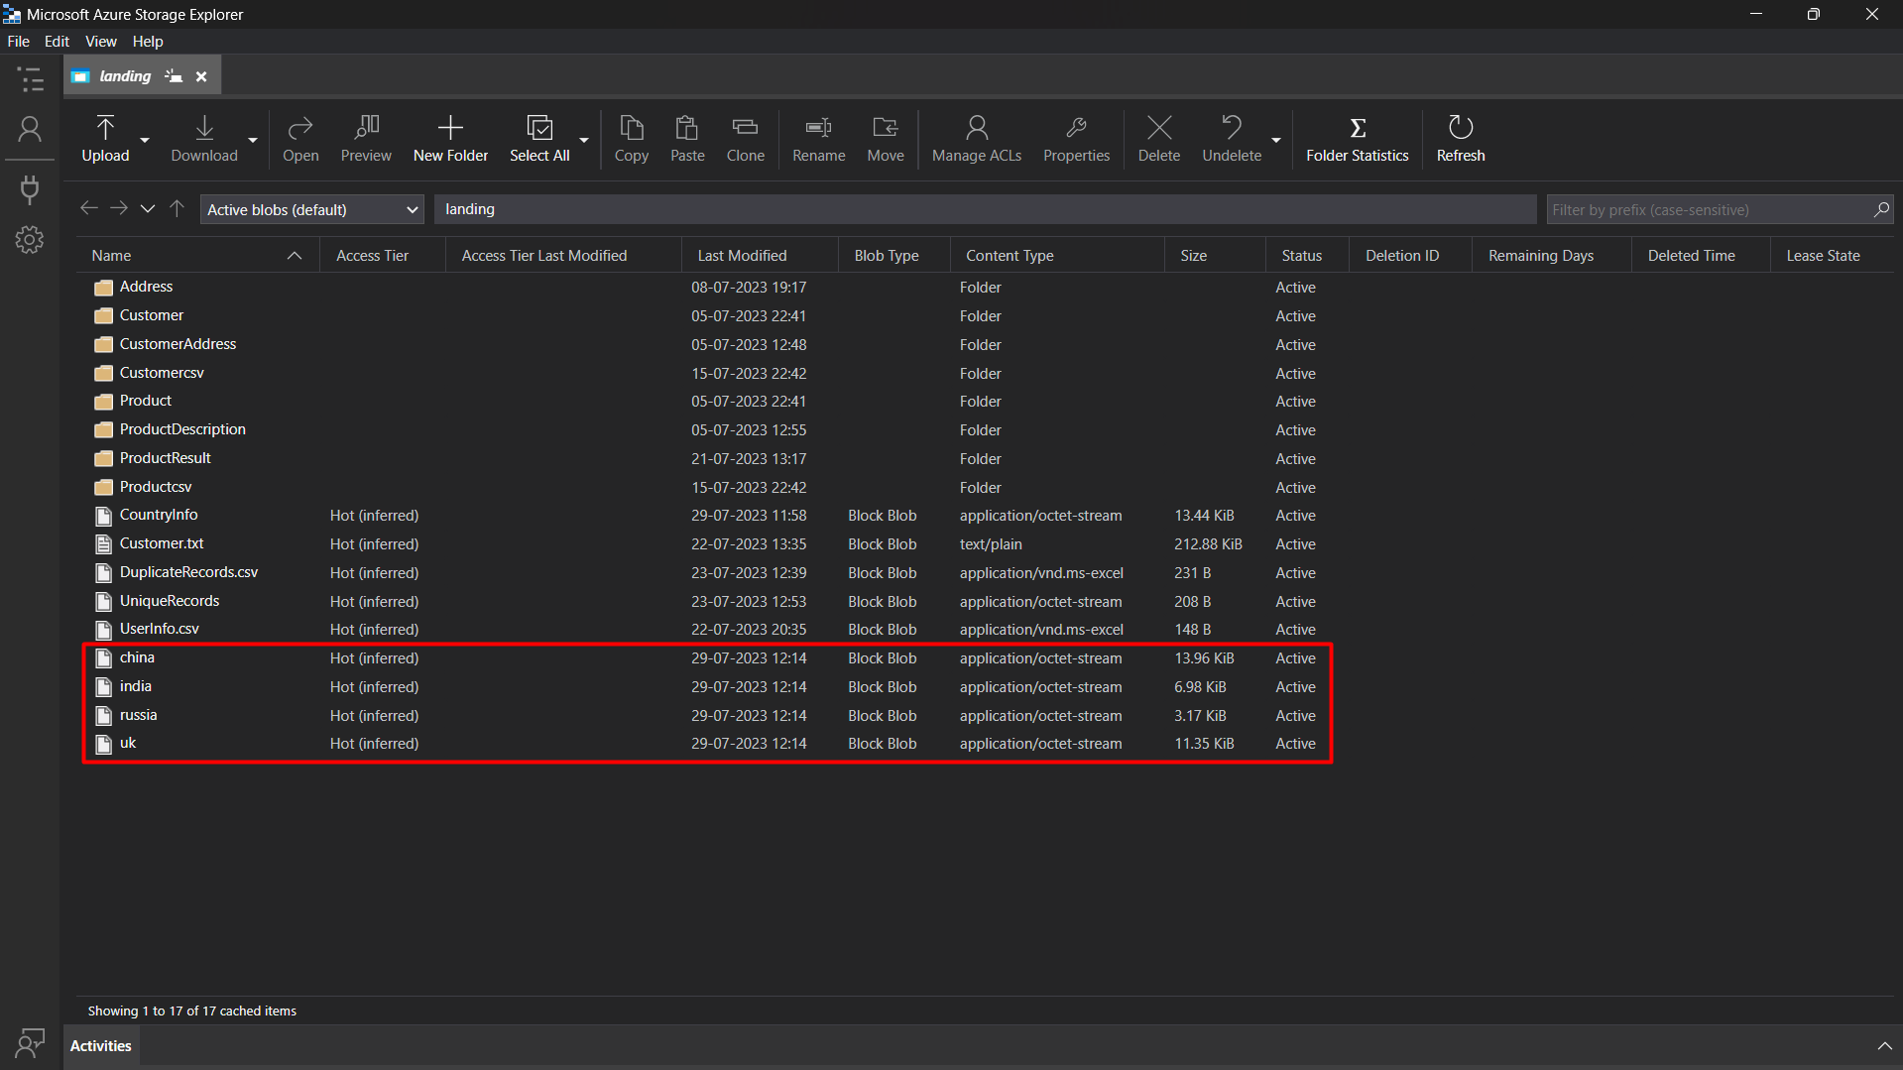

## Add the trigger to above pipeline in such a way that it will automatically run two times in a day ( 12:00 AM and 12:00 PM IST)

## Tip: In case you can't able to do Q2, do this on Q1

## Solution:

## 

## Now to make it more realistic, as soon as any copy activity fails in the above pipeline send an automated email to notify user.

## Solution:

## 

## Make the mail more generic by sending the Pipeline name, Status, Sender MailiD, and Name within the mail. Ensure mail will come in case of both success and fail.

## Solution:

## Once a file for India gets generated trigger a pipeline that will copy the India.json file as CSV into the ADLS account.

## Solution:

## 

## 

## 

## 